**DIRECTIONS FOR HOW TO SUBMIT PD ONTO AVATAR**

**(after SBPT has approved it)**

STEP 1: log onto AVATAR

STEP 2: Click on My Transcript in the left hand column

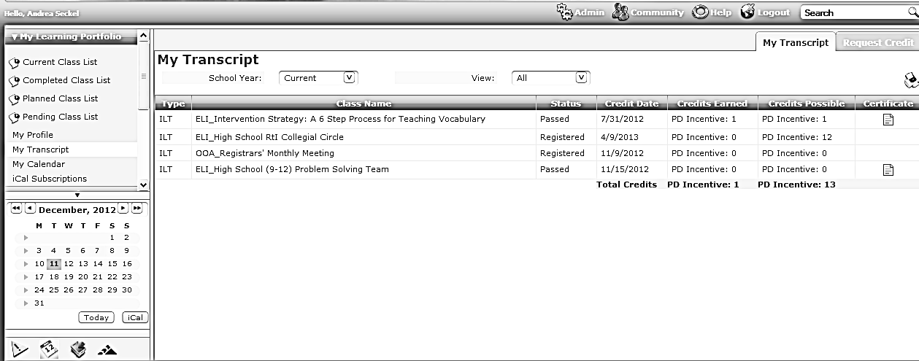

STEP 3: Click on Request Credit in the upper right hand corner

STEP 4: Scroll down to the bottom of the screen until you get to the New Request section

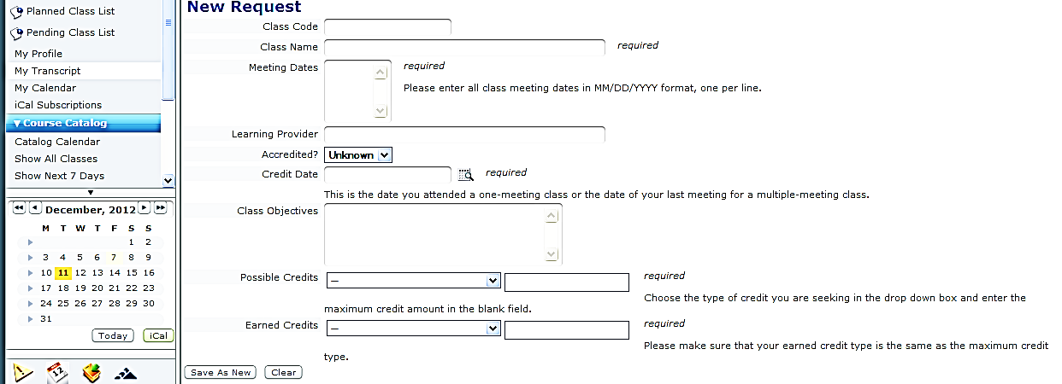

STEP 5: Fill in all required information

STEP 6: Click Save As New